eSEC F19-51-DRON

**“The Autonomous Rocket Drone”**

Preliminary Design and Proposal

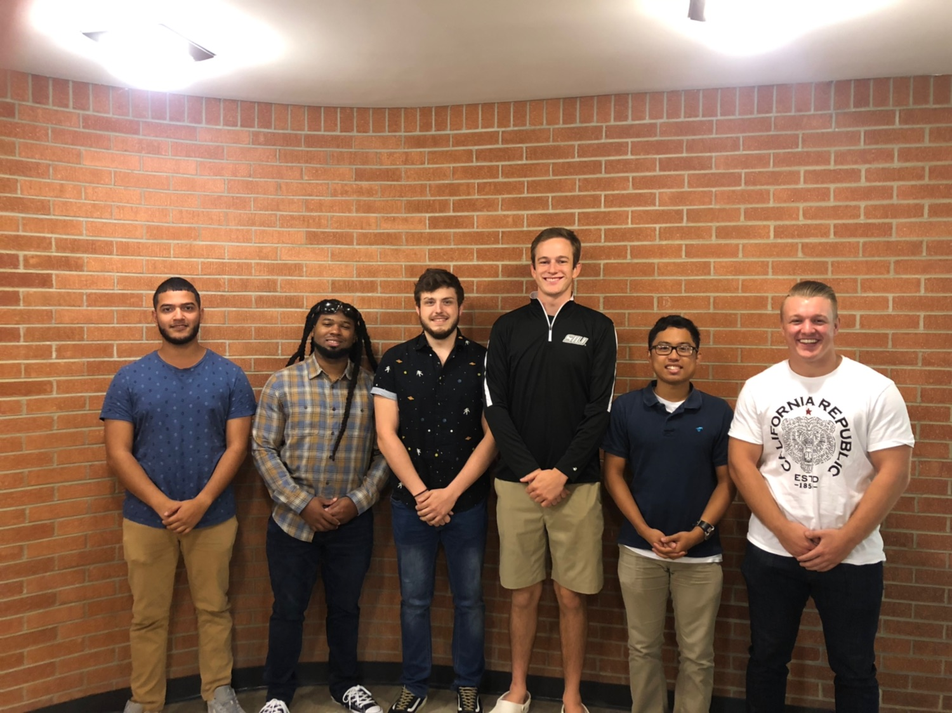Left to Right: Ryan Lampon (ME), Larry Herring (CE), Max Newhart (ME), Adam Vogel (ME), James Cabahug (ME), Sterling Lech (CE)



FTA: Michael Cubley and Frances Harackiewics; Instructors/Lab Coordinators-SIU

Client: Rocketeers of Southern Illinois

Southern Illinois University-Carbondale

Date: 1/13/2020

# SEC Non-Disclosure Agreement

The information provided in or for this proposal is the confidential, proprietary property of the Saluki Engineering Company of Carbondale, Illinois, USA. Such information may be used solely by the party to whom this proposal has been submitted by Saluki Engineering Company and solely for the purpose of evaluating this proposal. The submittal of this proposal confers no right in, or license to use, or right to disclose to others for any purpose, the subject matter, or such information and data, nor confers the right to reproduce, or offer such information for sale. All drawings, specifications, and other writings supplied with this proposal are to be returned to Saluki Engineering Company promptly upon request. The use of this information, other than for the purpose of evaluating this proposal, is subject to the terms of an agreement under which services are to be performed pursuant to this proposal.

# SEC Validity Statement

Saluki Engineering Company's proposal is valid for a period of thirty (30) days from the date of submittal. After this time, we reserve the right to review the content to determine if any modifications are necessary.

Dear Rocketeers of Southern Illinois,

On behalf of Saluki Engineering Company team F19-51-DRON, I would like to thank you for allowing us to submit our proposal for the design of an autonomous drone for use in future rocket competitions. Our team is very excited to work alongside Mayan Robotics to complete this task. F19-51-DRON is comprised of six members from varying backgrounds with excellent work ethics. We strongly suggest that the Product Engineering side of the rocket team contact us with any questions concerning the drone project. I can be contacted by phone at 309-838-2493, or by email at [adam.vogel@siu.edu](mailto:adam.vogel@siu.edu).

Sincerely,

Adam Vogel

F19-51-DRON Project Owner, Saluki Engineering Company

Table of Contents

**SEC Non-Disclosure Agreement** **1**

**SEC Validity Statement** **1**

**Background** **4**

Executive Summary (AV) 4

Introduction (MN) 5

**Purpose / Requirements** **5**

Major Design Challenge (SL) 5

Courses (MN) 5

Standards (MN) 6

Constraints (AV) 6

Tools (JC) 6

**Literature Survey (JC)** **7**

Introduction 7

Relevant Information From Literature 8

**Subsections** **8**

Airframe (MN) 8

Electronics (SL) 8

Programming (SL) 8

**Conclusion (AV)** **9**

**Appendix** **(RL) 9**

References 9

Block Diagram: 10

House of Quality: 11

Organization Chart: 12

Timeline: 12

Budget: 12

Engineering Standards: 13

Safety Plan: 13

Communications with Client and Sponsor: 13

Resumes of Team Members: 14

# 

# Background

## Executive Summary:(AV)

The Rocketeers of Southern Illinois (ROSI) is a student-led rocketry team at Southern Illinois University Carbondale. Their competition requires a rocket to reach 8,000 feet and then return a golf ball to the ground. In order to deliver the golf ball from a predicted altitude of 10,000 feet, the Rocketeers of Southern Illinois have tasked the F19-51-DRON team to construct a fully autonomous drone. The team is using a design that ROSI used last year to base their initial design on. Once a design is complete, the team will work in tandem with the aviation program at SIU to test the drone’s ability to autonomously fly.

This report will detail the team’s efforts and explain the thought process and justification behind each decision. The team is sponsored by Mayan Robotics, a company in Silicon Valley, that specializes in autonomous flight controllers. Mayan Robotics has agreed to cover the entire cost of design and is the team’s main source for purchasing supplies.

The project is comprised of three teams, each in charge of a specific area. Those teams include airframe, electronics, and programming. Airframe is focused on designing the body of the drone and has selected the material to be PLA plastic, printed by a 3D printer. Electronics is selecting the battery necessary to power the system as well as ensuring all electrical connections are strong enough. The programming team is in charge of programming the flight controller to fly a drone autonomously by editing the parameters listed in ArduPilot.

The deadline for this project is March 28th, the date of ROSI’s competition in the Argonia Cup. Regardless of the competition performance, further analysis and testing will be done in preparation for future competitions.

## Introduction: (MN)

The objective of this project is to design, manufacture with additive techniques, and test an autonomous drone in preparation for the Argonian Cup competition which incorporates the aforementioned drone within a specialized rocket designed by ROSI. The job taken on is to redesign this drone with larger airframe specifications as well as incorporate a newly designed wing-joint mechanism to allow for ease of deployment. With the first version of the autonomous drone manufactured, there were multiple design criteria that needed adjustment to allow for proper flight of the drone, as well as proper deployment of the folded wings used by the drone.. Within completion of this design and its parts, there are many applications in which these implications and designs could be useful within different aspects of the world of engineering and encompassing principles.

# Purpose / Requirements

## Major Design Challenge: (SL)

This problem constituted a major design experience for the Mechanical Engineering students through the physical design of the drone through CAD modeling. The physical design of the drone will require further analysis to determine the most preferable dimensions for better aerodynamics. The major design experience for the Computer Engineering students will be programming the drones onboard microcomputer. Optimizing the onboard microcontrollers flight algorithm for the drones most accurate and efficient flight path.

## 

## Courses: (MN)

* ME 477 - Fundamentals of Computer-Aided Design and Manufacturing
  + Use of CAD principles including geometric modeling techniques
* ME 478 - Finite Element Analysis in CAD
  + Finite element analysis and modeling
* ECE 296 - Introduction to Software Tools and Robotics
  + Basic Programming Principles using Microcontrollers
* ECE 321 - Introduction to Software Engineering
  + Basic Programming Principles
* ECE 222 - Introduction to Digital Computation
  + Basic Programming Principles

## Standards: (MN)

* [IEEESTD.1942.7407275](https://doi-org.proxy.lib.siu.edu/10.1109/IEEESTD.1942.7407275)
  + Standards for electronic apparatus’ under various atmospheric conditions
* [IEEESTD.2018.8445674](https://doi-org.proxy.lib.siu.edu/10.1109/IEEESTD.2018.8445674)
  + Standard for small-scale embedded systems and circuitry
* [IEEESTD.2009.5226540](https://doi-org.proxy.lib.siu.edu/10.1109/IEEESTD.2009.5226540)
  + Standard for Inertial navigation, guidance, orientation, stabilization
* ASME Y14.5M-1994
  + Dimensioning and tolerancing engineering drawings

## 

## 

## Constraints: (AV)

In order to successfully complete the project, F19-51-DRON must work within the requirements of the Argonia Cup competition rules in addition to the physical constraints of the rocket itself.

The Argonia Cup competition requires a minimum altitude of 8,000 feet, followed by delivering a golf ball to a specified location on the ground. The drone must be able to fit inside of the rocket. The rocket has an interior diameter of **5”** and the length of the drone can not exceed **25”.** In addition, the drone must be able to expand by itself upon exiting the rocket and begin its descent. Additionally, the drone may not exceed **20 ft/s** for the final 800 ft of flight. This is a safety measure to ensure golf balls aren’t haphazardly thrown around.

## Engineering Tools: (JC)

* Software used for 3D modeling every part of the drone.
* CAD/Autodesk Inventor  
  Digital Caliper  
  Device for measuring each length for 3D modeling
* 3D Printer  
  Print parts in PLA material

# 

# 

# 

# 

# Literature Survey (JC)

## Introduction:

The drone has remarkable applications in a rapidly changing and highly technical society. Drones are known as Unpiloted Aircraft System (UAS) potentially used for surveillance. They are lightweight, relatively inexpensive, safe, and commercially sustainable in the aviation industry. Compared to piloted aircraft systems, drones are “more agile, accessible, affordable, adaptable, and more capable of anonymity” (Bartsch, Coyne, Gray, 2017, p.3). While UAS has several advantages, there are challenges that arise in modern society, such as its complicated design despite the size being small. Selecting the most effective material for the drone design would ideally satisfy all the constraints while maintaining strong mechanical and electrical properties. Additionally, full automation of drones are “strongly spurred by the technical advancement of communication and information technologies and their miniaturization” (Bartsch, Coyne, Gray, 2017, p.15). New regulations from the aviation industry will allow greater drone flexibility in achieving safety outcomes.

## Relevant Information From Literature:

In order to pilot a drone from a predetermined location, a radio signal is sent through a remote control system. The transmitter controls the drone and sends a radio signal to the antennas in the receiver. Electric current is then generated in an oscillator circuit, and it activates servo motors in the drone, which can rotate gears, adjust flaps, operate propellers, etc. The power source, furthermore, is typically provided by batteries. Radio and communication are the most important parts of the drone to make these flights sustainable.

Drones have become quite popular in the aviation industry. Namely, “Teal Group studies predict a doubling in the value of the UAV market, [including] jobs, products, attached equipment and related industries” (Bartsch, Coyne, Gray, 2017, p.137). The solutions that the innovative drone design offers to problems will be taken to a whole new level. For example, suppose a drone and golf ball are placed in a rocket. After the rocket launches thousands of feet high, it would be possible to transport a golf ball back to the ground safely. An optimized drone design would achieve this autonomous task.

Discussion of Standards in Literature:

Australia has developed a new standard for the unmanned aircraft industry, known as the Unmanned Aircraft System International (UASi) standard. This standard is “the world’s first risk-based safety and auditing standard for unmanned aircraft operations” (Bartsch, Coyne, Gray, 2017, p.42). Safety experts in the field of unmanned aircraft certification developed this standard to ensure all drones are operated safely. The UASi standard is also in accordance with other regulated standards. These safety experts were finding innovative solutions to significantly decrease the number of unmanned aircraft accidents.

# Subsections

## Airframe: (MN)

An outsourced company, Mayan Robotics, will aid in the development of this autonomously guided drone. It is unclear whether the F19-51-DRON will be the sole developers of the new version of the drone, or the partner company mentioned will be taking care of some of these processes. The new design will consist of larger overall specifications for the drone in order to incorporate into a larger diameter rocket assembly.

## Electronics: (SL)

The only electronic component that the drone requires is the onboard PIXRacer. The PIXRacer is the drones onboard microcontroller which is capable of controlling the drones servos that manipulate the drones flight path during its descent from the rocket to the specified point on the ground. Future upgrades and changes in parts for the microcontroller will be applied occasionally throughout the research process.

## Programming: (SL)

The PIXRacer uses an Interface for controlling the drone known as Ardupilot. The basic structure of ArduPilot is broken up into 5 main parts:

* **Vehicle Code -** Top level directory that defines the firmware(permanent software located in read only storage on the hardware) for how the microcontroller should behave.
* **Libraries -** Libraries are shared among each vehicle. Libraries include sensor drivers, position estimation, and control code.
* **Hardware Abstraction Layer -**  Defines the interface that the rest of the code has to our specific board(PIXRacer)
* **Tools Directories -** Miscellaneous support directory which will provide test results from trial runs
* **External Support Code -** On some platforms, we need external support code to provide additional features or board support.

# 

# Conclusion (AV)

The goal of this project is to create a fully autonomous drone that can deliver a golf ball from 10,000 feet to a specific location on the ground. This has never successfully been done before so existing literature is quite scarce. However, applicable literature and standards have been discussed above. Each subsystem was thoroughly explained and related directly to the finished product. The preliminary design effectively follows the constraints and standards listed above. After further communications with the client and sponsor take place, construction will begin by the end of this semester. The finished product will meet every constraint given by ROSI and will exceed performance expectations.

# 

# 

# 

# Appendix

## References (RL):

A. S. H. I. S. H. TEWARI, *BASIC FLIGHT MECHANICS: a simple approach without equations*. Place of publication not identified: SPRINGER, 2018.

Bartsch, R. (2018). *Drones in Society : Exploring the Strange New World of Unmanned Aircraft*. Taylor & Francis Group.

Mmaack, “Logistics,” *The Argonia Cup*. [Online]. Available: http://www.argoniacup.com/logistics. [Accessed: 24-Oct-2019].

N. Larrieu and A. Varet, *Rapid prototyping of software for avionics systems: model-oriented approaches for complex systems certification*. London: ISTE Ltd, 2014.

“Reference geometry,” *Autodesk Support & Learning*. [Online]. Available: https://knowledge.autodesk.com/support/inventor-products/learn-explore/caas/CloudHelp/cloudhelp/2015/ENU/Inventor-Help/files/GUID-91FD3F86-7117-4353-98AE-2B6BFDA1F5CA-htm.html. [Accessed: 24-Oct-2019].

## 

## Block Diagram:



## House of Quality:

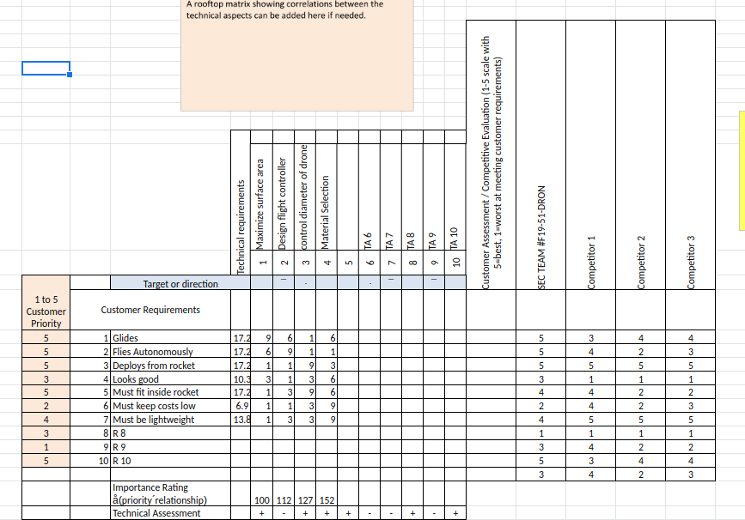

## Organization Chart:



## Timeline

Sprint 1: August 19 - September 2nd | Getting up to speed, deside on prototype design, gather previous micro electronics used in the last Argonia Cup competition.

Sprint 2: October 3 - November 5 | Analyze current microcontroller, Analyze 3D printing options, Construct Prototype drone design.

Sprint 3: November 5th - November 12 | Find servos for drones wings, Model design in Autodesk inventor, run FEA analysis for structural integrity of wing design, spring load the wing expanding design.

Sprint 4: November 12th - November 15th | Complete finite element analysis, analyze mRo Control Zero board specifications and pin connections, select hinge design for drone wings, decide on 3D printing method of drone.

Due to lack of communication with Mayan Robotics timeline specifics are fickle.

## Budget (RL):

Graciously paid for through Mayan Robotics. Depends on communications with said sponsor which have not occurred yet.

## Design Figures:

FEA results for old and new drone hinge design:

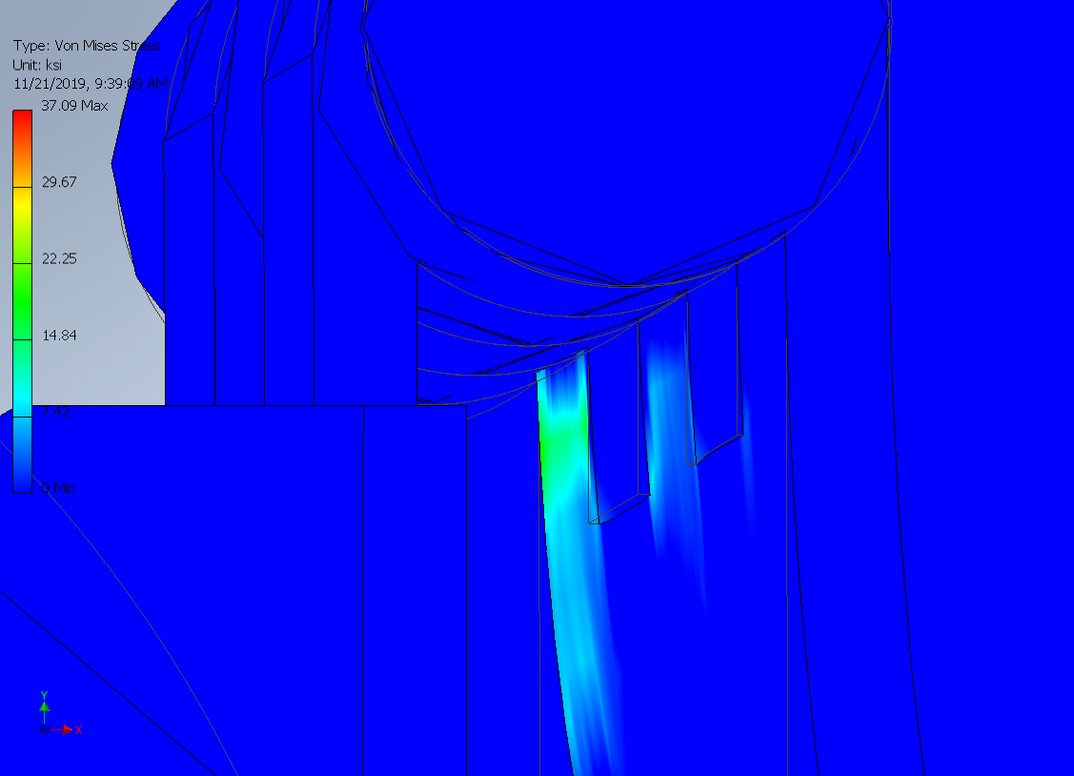

Figure 1: Hinge Stress Analysis from old drone

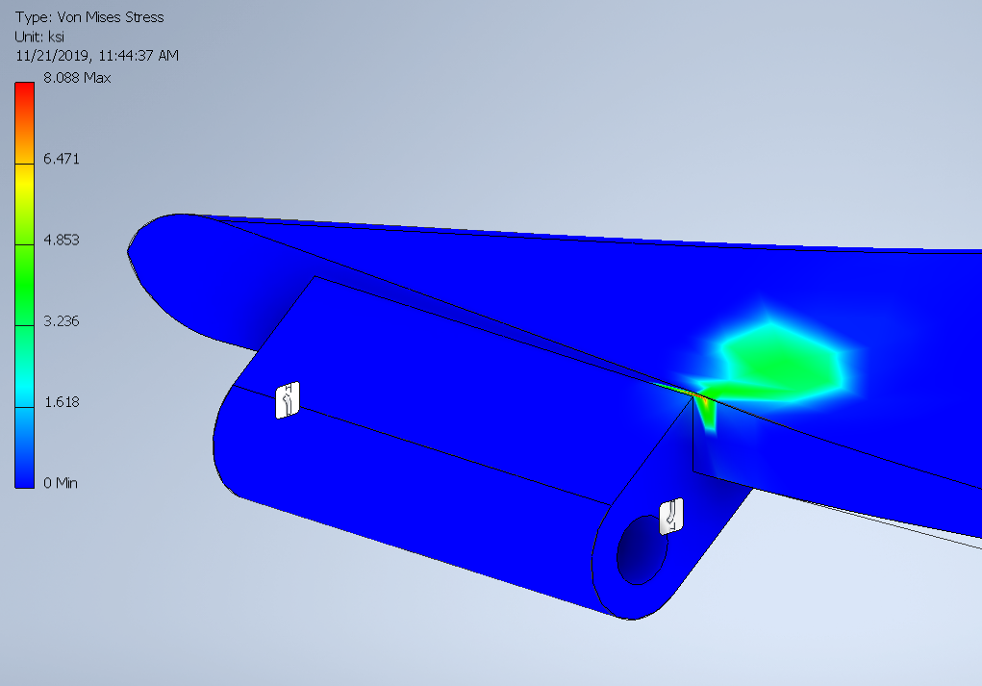

Figure 2: Stress Analysis for New Hinge A

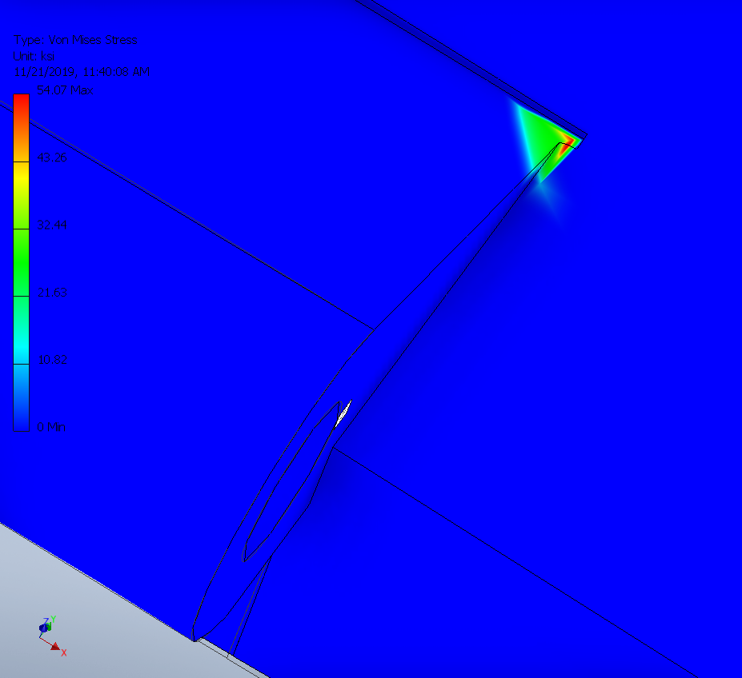

Figure 3: Stress Analysis for New Hinge B

## Engineering Standards:

* [IEEESTD.1942.7407275](https://doi-org.proxy.lib.siu.edu/10.1109/IEEESTD.1942.7407275)
* [IEEESTD.2018.8445674](https://doi-org.proxy.lib.siu.edu/10.1109/IEEESTD.2018.8445674)
* [IEEESTD.2009.5226540](https://doi-org.proxy.lib.siu.edu/10.1109/IEEESTD.2009.5226540)
* ASME Y14.5M-1994

## Safety Plan (RL) :

No hazardous materials were used in this project. For minor mechanical alterations to drone, all Shop Machine Safety Procedures will be rigorously enforced.

## Communications with Client and Sponsor:

Sponsor has been largely unresponsive for the first half of the semester

Resumes of Team Members:

## 

## 

